

**“VASUNDHARA”**

***Project Final report submitted***

***in***

***partial fulfillment of requirement for the award of***

***degree of***

**Bachelor of Engineering**

**in**

**Computer Science and Engineering**

***by***

**Ms. Niharika Dayama Ms. Anuja Tomar**

**Ms. Mansi Tardeja Mr. Rutvik Pohankar**

***Guide***

**Prof. Apeksha Sakhare**

**

**Department of Computer Science and Engineering**

G.H. Raisoni College of Engineering, Nagpur

(An Autonomous institute affiliated to Rashtrasant Tukdoji Maharaj Nagpur University, Nagpur)

**November 2020**

**Declaration**

We hereby declare that the project report titled “Vasundhara” submitted herein has been carried out by us in the partial fulfillment of requirement for the award of degree Bachelor of Engineering in Computer Science and Engineering. The work is original and has not been submitted earlier as a whole or in part for the award of any degree / diploma at this or any other Institution / University.

We also hereby assign to G. H. Raisoni college of Engineering, Nagpur all rights under copyright that may exist in and to the above work and any revised or expanded derivatives works based on the work as mentioned. Other work copied from references, manuals etc. are disclaimed.

**Place: Nagpur NIharika Dayama Anuja Tomar**

**Date: 30/10/2020 Rutvik Pohankar**

**Mansi Tardeja (Name and Signature)**

**Certificate**

The project report titled “**Vasundhara”** submitted by Niharika Dayama**,** Anuja Tomar**,** Mansi Tardeja and Rutvik Pohankar for the award of Bachelor of Engineering in Computer Science and Engineering has been carried out under our supervision. The work is comprehensive, complete and fit for evaluation.

|  |  |
| --- | --- |
| **Dr. Prashant Borkar**  **Head**  Department of Computer Science and Engineering G.H.R.C.E, Nagpur | **Guide Name**  **Assistant/Associate Professor**  Department of Computer Science and Engineering G.H.R.C.E, Nagpur |

**ACKNOWLEDGMENT**

**Abstract**



**PROJECT:** VASUNDHARA

**ABOUT THE PROBLEM:**

“Every action has an equal and opposite reaction”. No matter how technically efficient we become, the environment faces the repercussions of inhumane activities. To mitigate this, many unheard heroes have initiated efforts but being technologically inefficient their ideas fail to reach the potential crowd.

**PRIMARY REASON TO SELECT THE TOPIC:**

1. To provide the people who ensure us a secure future with a platform to broadcast their renovation and ideas to the entire world.
2. Also, as the youth of the nation, we have tried a small initiative to shoulder our responsibilities towards Mother earth by supporting the ideology of reusing, restoring and replenishing.

**PRIMARY OBJECTIVE:**

The project being non-profitable, aims at providing a virtual platform to the innovative ideas that have potential of becoming harmless,reliable and economically efficient products.

The project upon its completion would act as a conduit that would channel the informative flow of innovations amongst the potential customers and funders.

**SCOPE OF THE PROJECT:**

This project will provide a website dedicated to the unrecognized startups that aim to create eco-friendly products. This website will be designed to maximize the

consumption of these products by providing tools to channel the provider and consumer which would otherwise have to be done manually. The website will be easy to understand and use.

**List of figures**

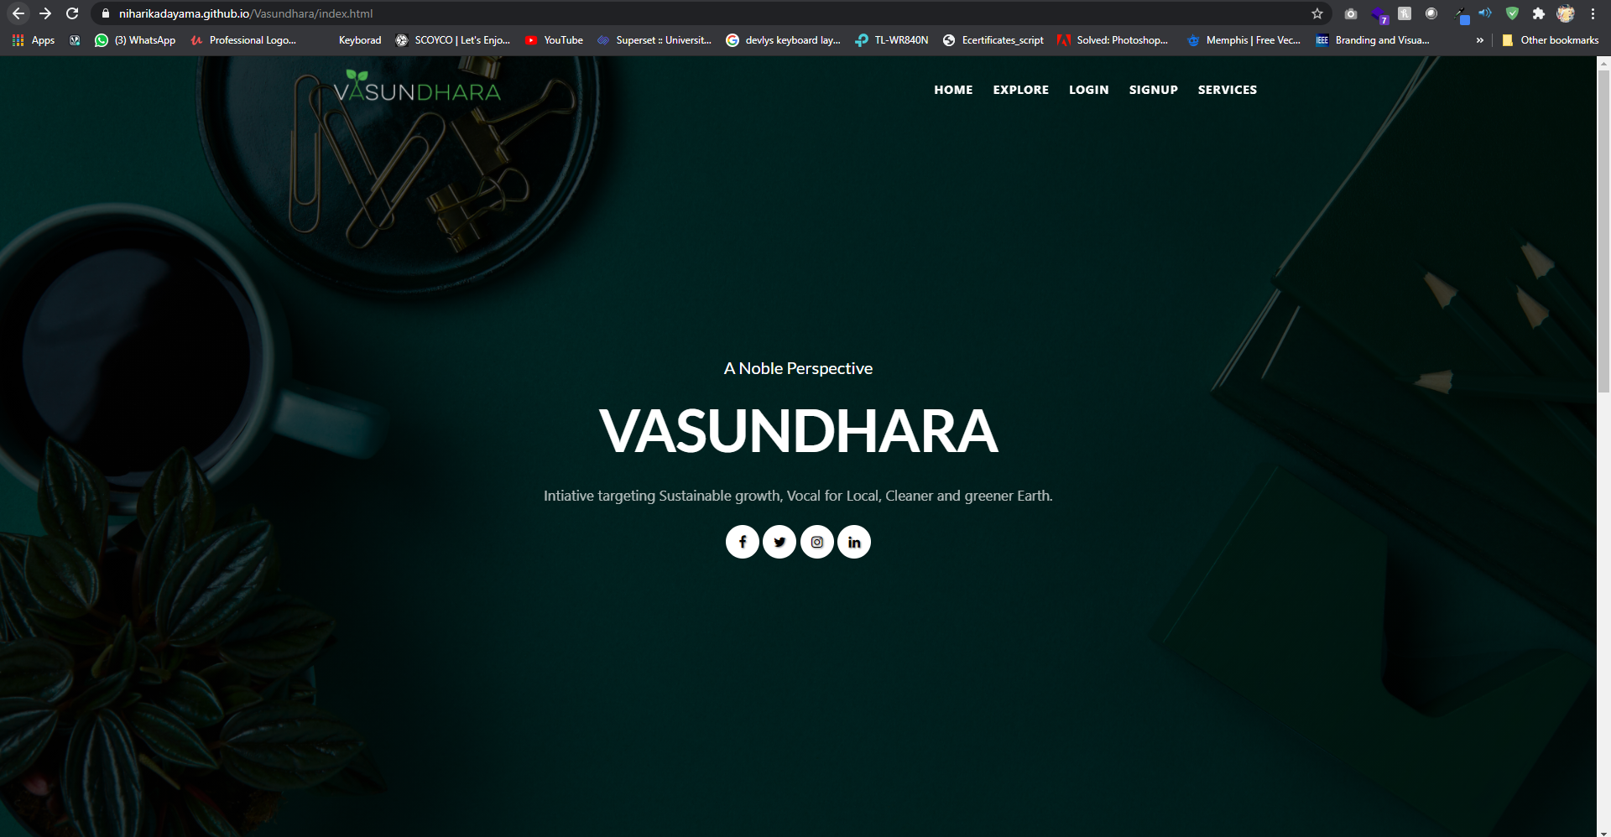

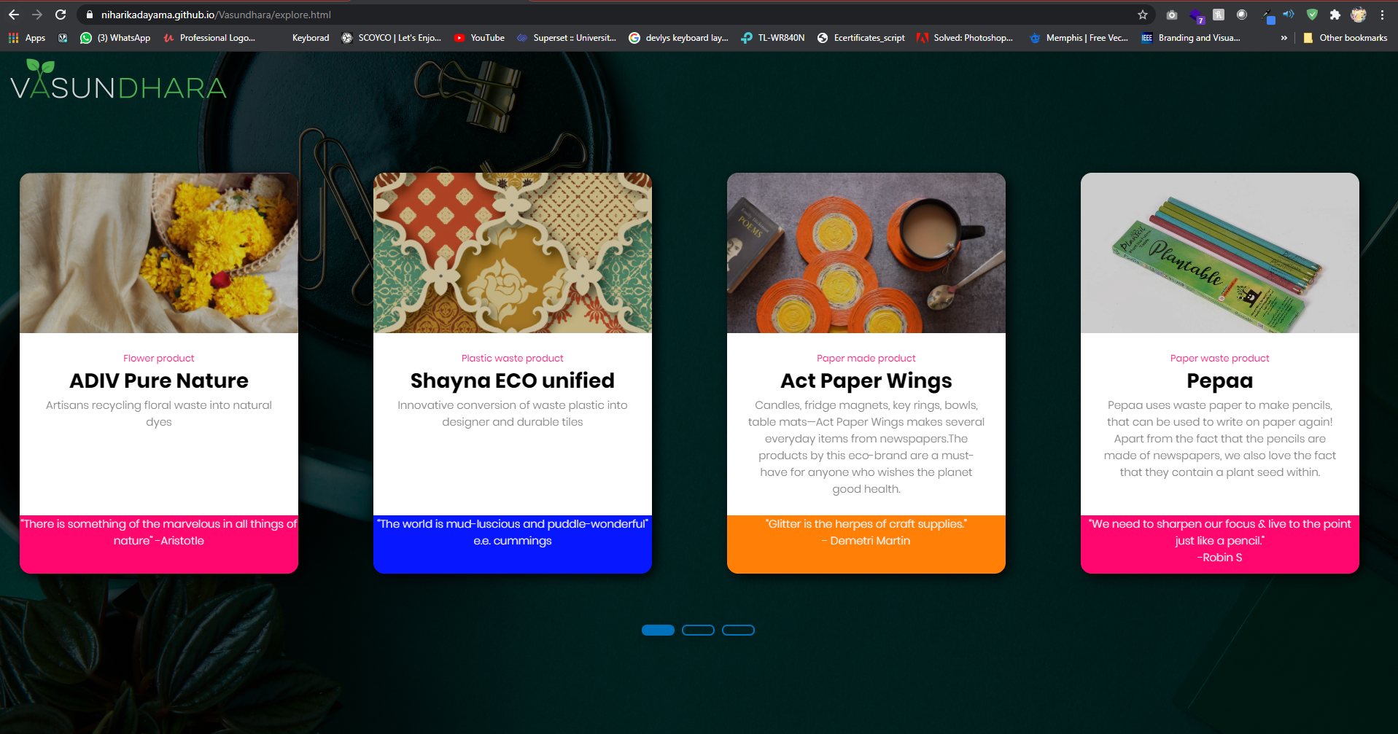

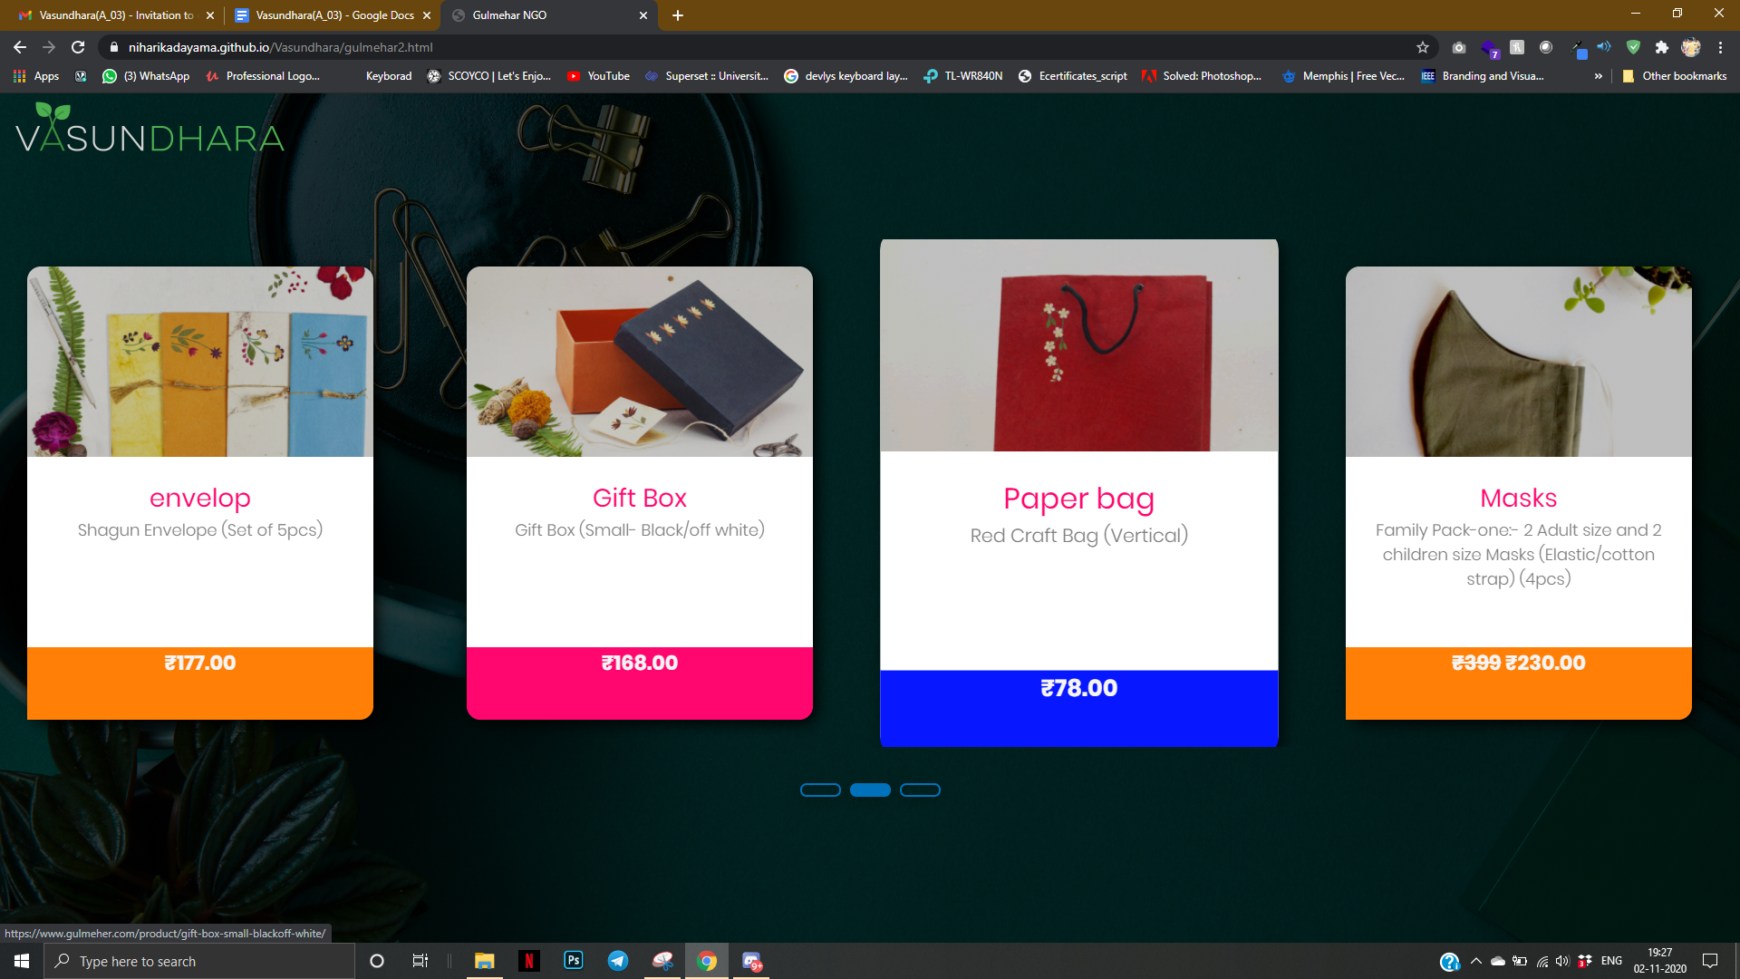

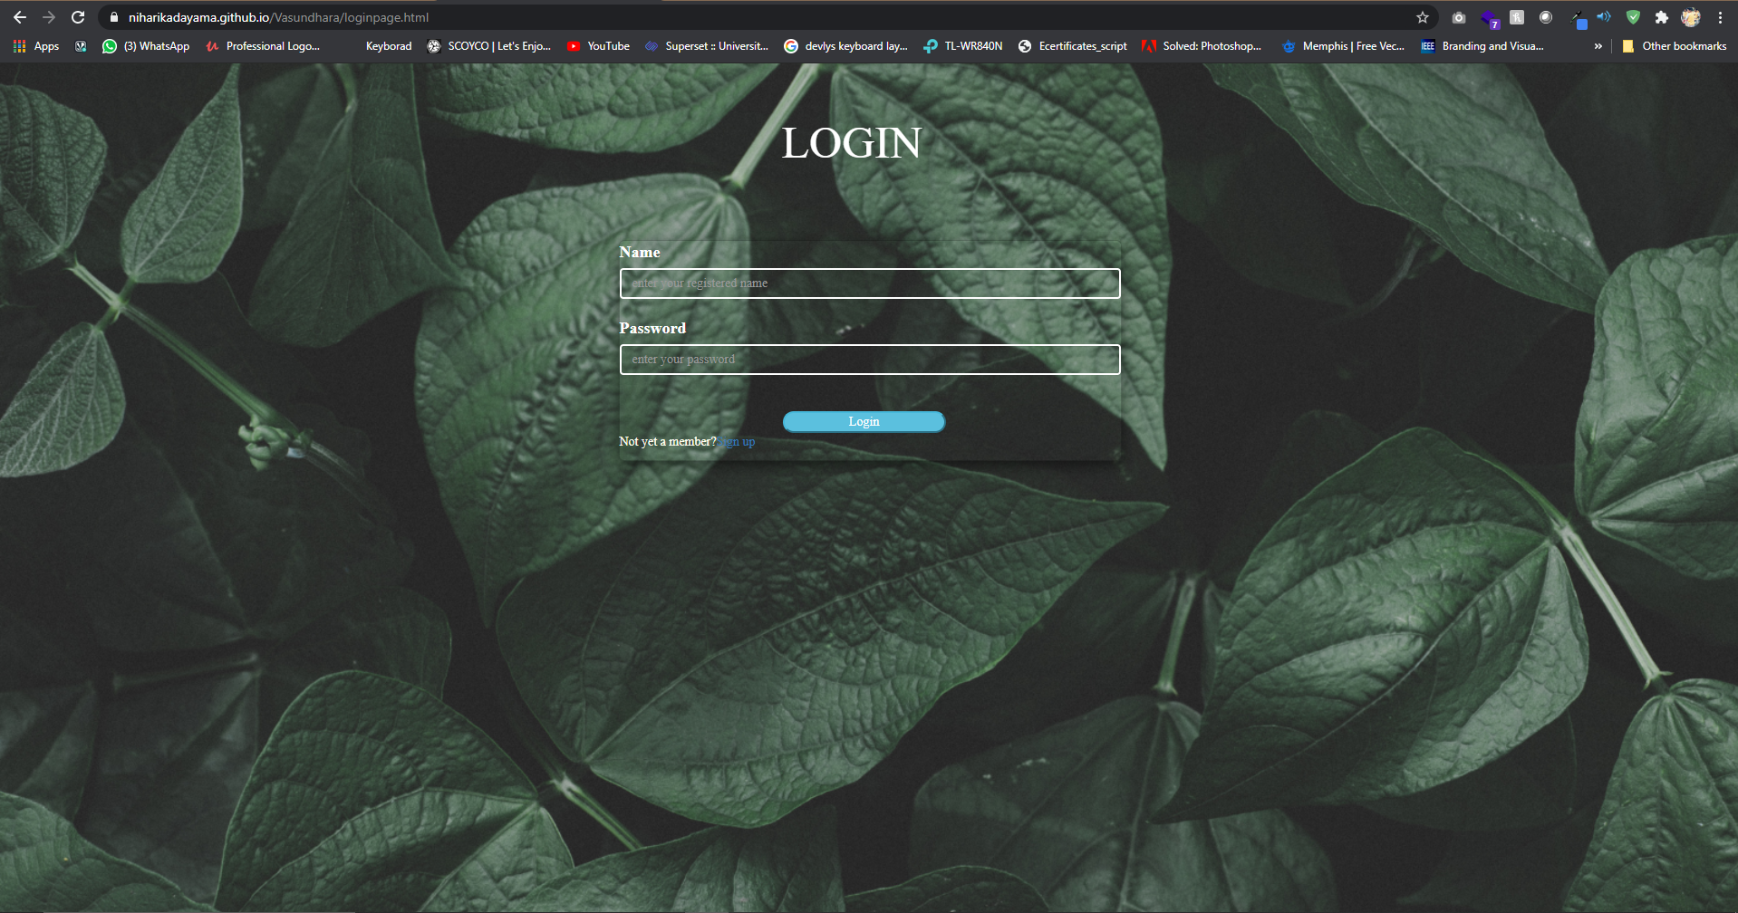

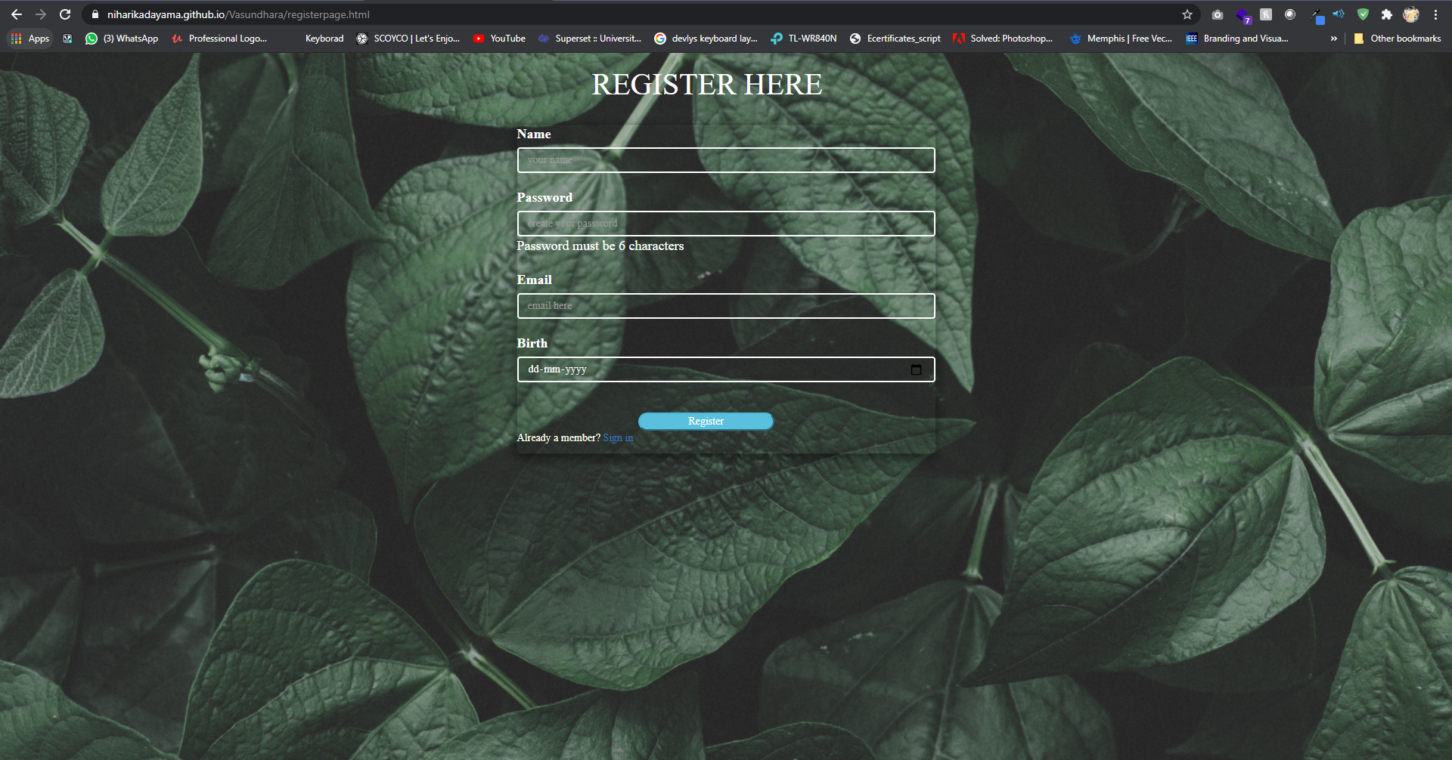

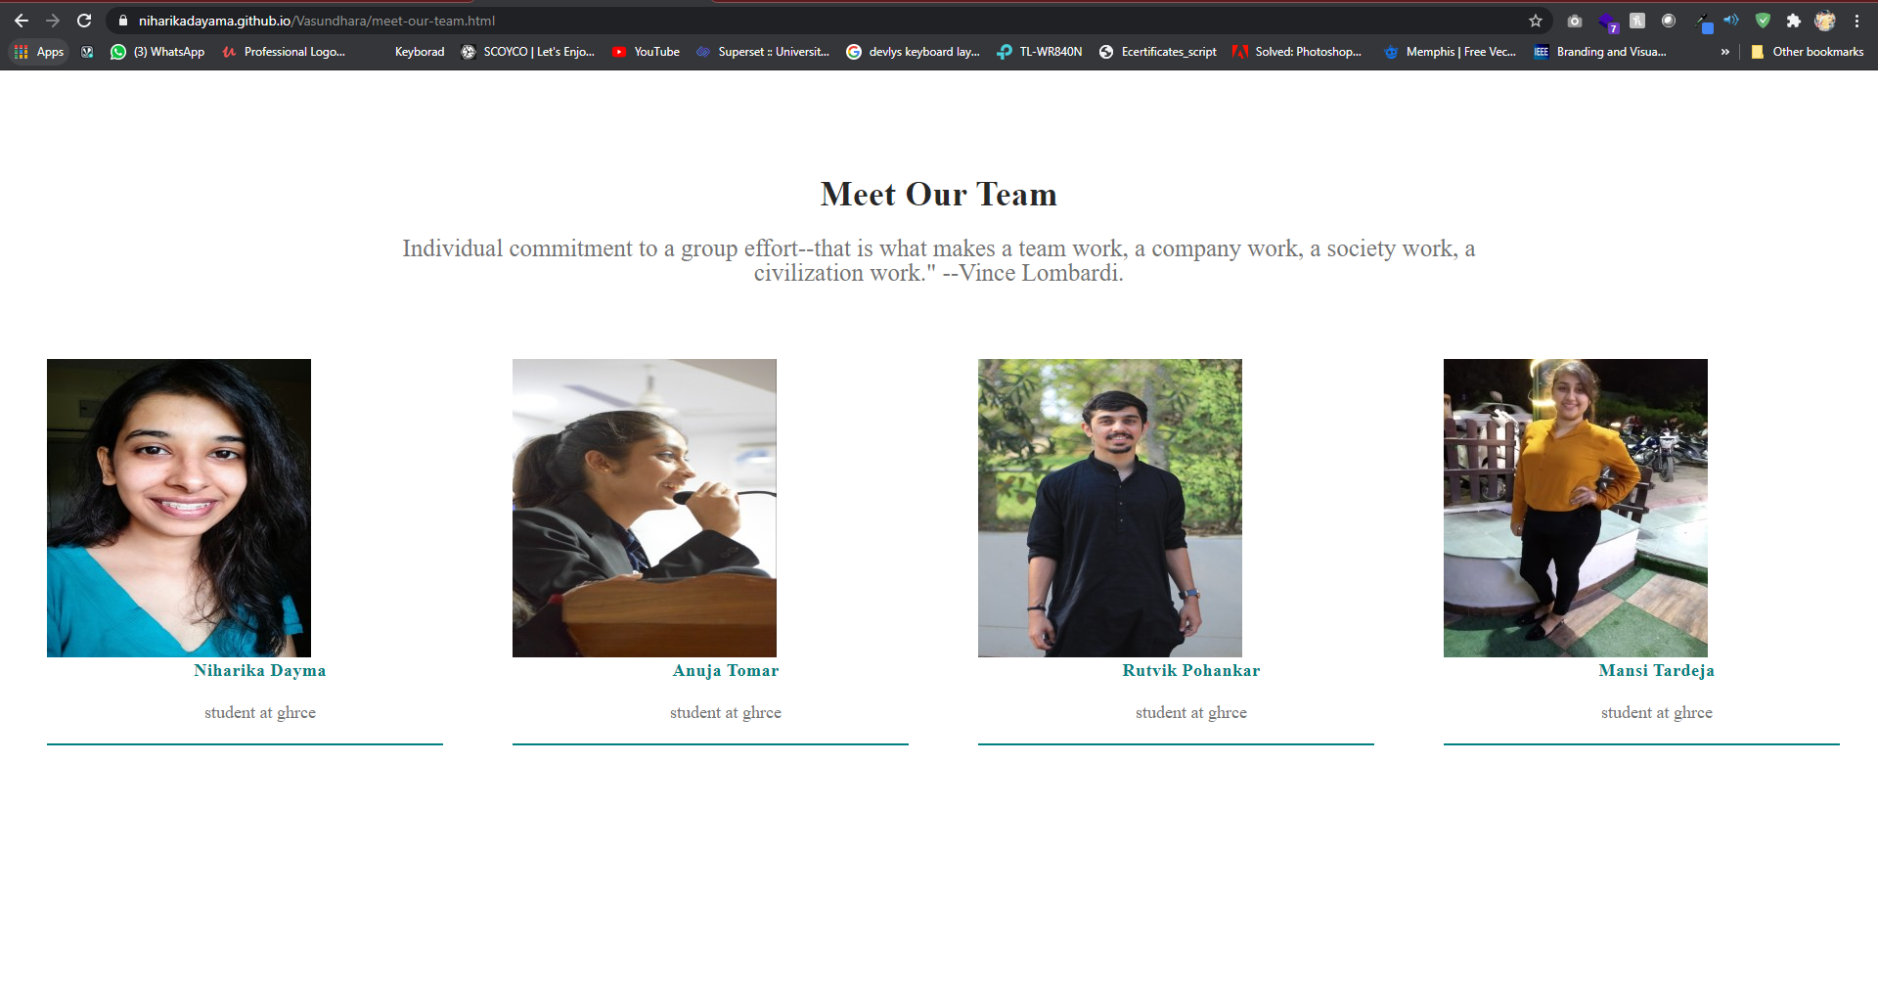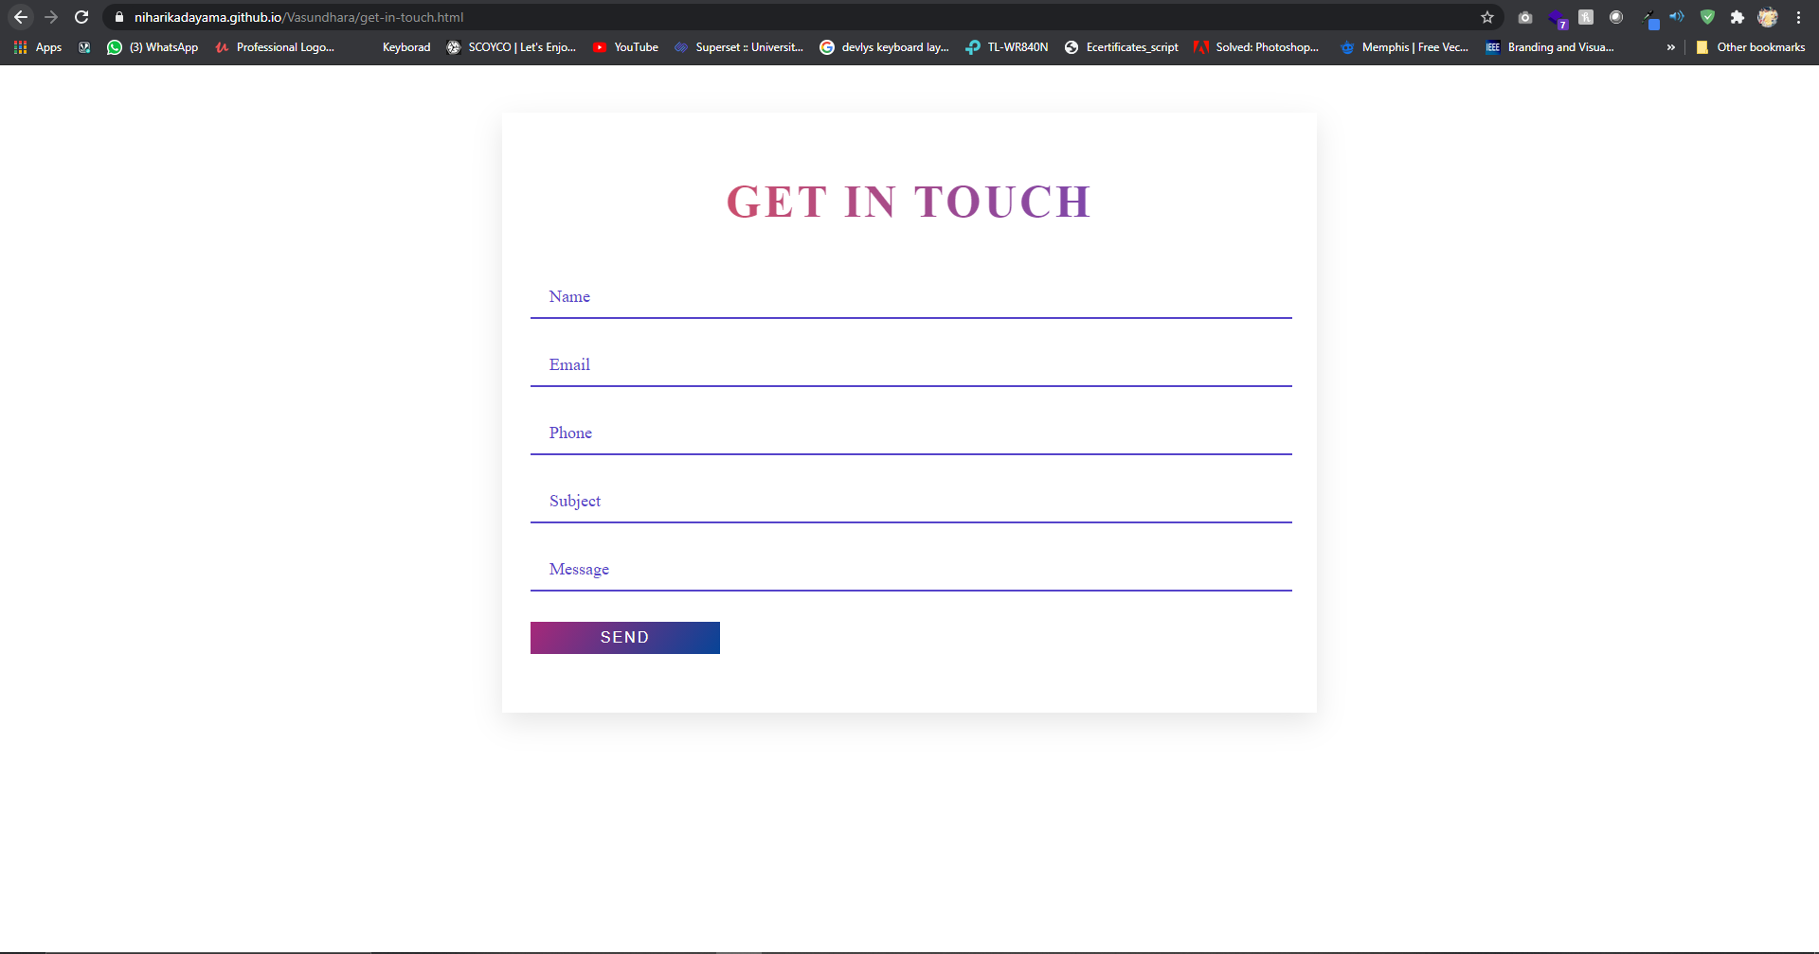

**List of Tables**

1. **User-registration table.**

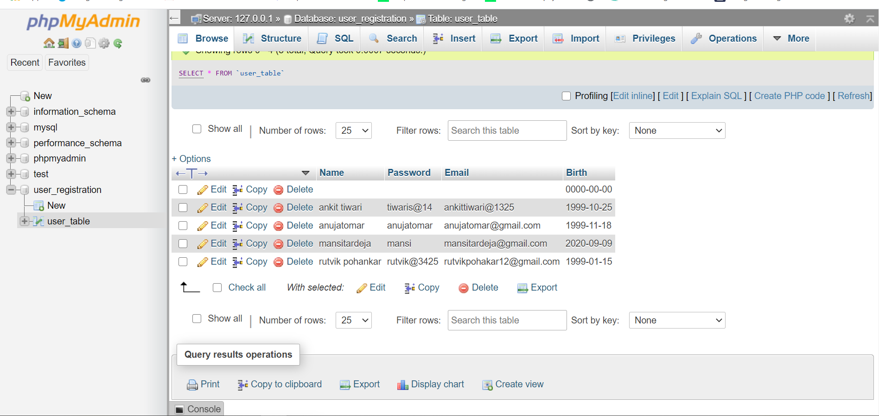

**INDEX:**

|  |  |  |
| --- | --- | --- |
| **Sr no.** | **Topic** | **Pages no.** |
| **1** | **Introduction** | **2** |
| **2** | **Methodology** | **2** |
| **3** | **Tools / Platforms used** | **3** |
| **4** | **Implementation** |  |
| **5** | **Testing & Summary of Results** | **5** |
| **6** | **References** |  |

**INTRODUCTION**

The project being non-profitable, aims at providing a virtual platform to the innovative ideas that have potential of becoming harmless,reliable and economically efficient products.

The project upon its completion would act as a conduit that would channel the informative flow of innovations amongst the potential customers and funders.

This project will provide a website dedicated to the unrecognized startups that aim to create eco-friendly products. This website will be designed to maximize the

consumption of these products by providing tools to channel the provider and consumer which would otherwise have to be done manually. The website will be easy to understand and use.

**METHODOLOGY**

1. Our project is a combination of a waterfall model and iterative model, the proposed methodology used is spiral model.
2. Each phase in our project begins with a design goal and ends with the client reviewing the progress.
3. Additional functionality or changes can be done at a later stage.
4. Development is fast and features are added in a systematic way.
5. There is always a space for customer feedback.

**PHASES OF PROJECT:**

1. **Planning :**

We understand the system requirements for continuous communication between the system analyst and the customer.

1. **Risk Analysis:**

Identification of potential risk is done while risk mitigation strategy is planned and finalized.

1. **Engineering:**

It includes testing, coding and deploying software at the customer site.

1. **Evaluation:**

Evaluation of software by the customer.

**TOOLS USED:**

**Hardware :**

No hardware required.

**Software:**

1. **Text editor:** Visual studio code, Sublime text.
2. **Database:** MySql.
3. **Server:** Xampp (provisional)
4. **Document editor:** Google Docs, Latex.

**TESTING AND RESULT SUMMARY:**

TESTING TECHNOLOGIES

1. WebPageTest
2. GTmetrix
3. Testcomplete

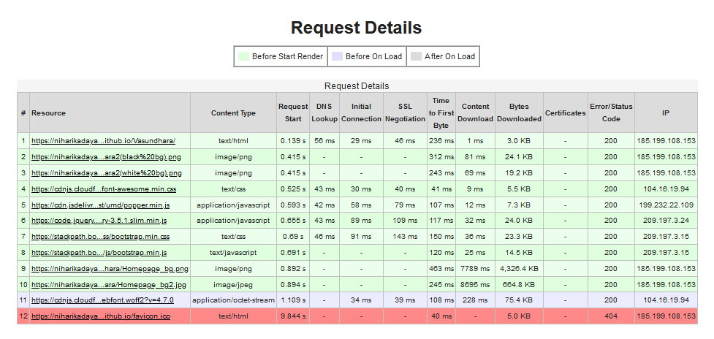 TEST RESULTS BY WEBPAGE TEST: